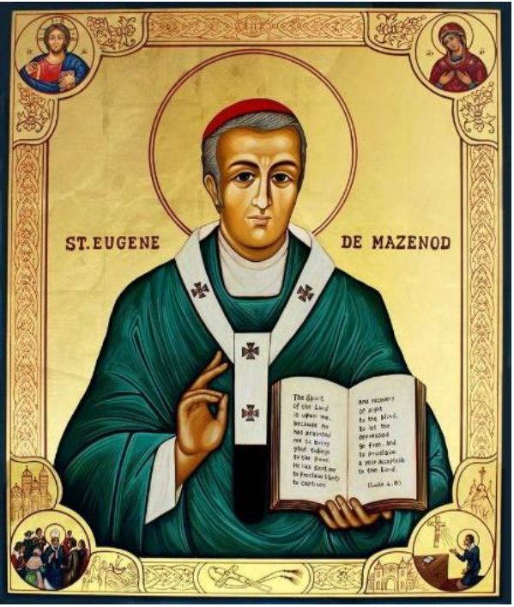
25th anniversary of canonization
of Saint Eugene de Mazenod
1995 – December 3 – 2020

Outlines for personal reflection

and community dialogue
The 25th anniversary of the canonization of St. Eugene, which took place in Rome on December 3,1995, is an occasion not only to celebrate this event that has marked the life of the Congregation, the Diocese of Marseille and many faithful, but also to reflect on the relationship we have with our Founder and how we share his legacy of holiness and mission. We offer three outlines for moments of personal reflection and community dialogue. The first is more elaborate, the other two can be further developed according to different needs.

First outline
On the occasion of his canonization, the Superior General, Fr. Marcello Zago, proclaimed a Mazenodian Year and wrote a Letter to the whole Congregation as an “instrument of exchange, evaluation and discernment,” inviting “to use it also in community meetings” (Se renouveler dans le charisme d ‘Eugene de Mazenod, 1995). That letter can still help our reflection and sharing. In it he invited us to fix together our gaze on the Founder, considering him in many ways:

A saint to imitate
Zago points out above all the Founder’s determination and tenacity in pursuing holiness, which has been expressed in these points:
1. relationship with Christ: a fresh, direct, personal, and concrete relationship;
2. search for the Father’s will: letting himself be guided by the Spirit;
3. attention to others, sensitive to their needs, ready to come to their aid: the salvation of souls guided his missionary sense and became more and more a motive for his apostolic action;
4. unconditional service of the Church;
5. vast horizon and an open love for humanity;
6. ability to take a position and change his positions even if it cost him;
7. fidelity to the daily reading of Scripture, which influenced his vision of faith, his prayer, and his understanding of evangelization.
Is Saint Eugene a model for me? Do we know his path of holiness? What are the traits of his holiness that can inspire us?

A founder to follow
Zago suggests some lines of reflection:
1. To understand the charism of one’s own Institute, one must understand the Founder and be in tune with him, his inspiration and his project.
2. Eugene places Jesus Christ the Savior at the heart of the project of evangelization. Starting from it, he formed his Congregation on three main values: the mission of evangelizing the poor, community life, and the commitment to sanctification of the members themselves.
3. The priority of his project was evangelization, which was born of perceived urgency and aimed to make the recipients first human beings, then Christians, and finally, saints.
4. The community was considered essential from the beginning, based on the experience and model of the apostles.
5. The commitment to holiness was born of missionary needs, because the proclamation of the Gospel requires preachers who are above all, witnesses. The choice of religious life with the practice of vows and its ascetic demands was the natural consequence.
6. Other dimensions characterize it, such as the choice of the poor and the abandoned, the priestly character, devotion to Mary, love for the Church, attention to urgent pastoral needs, commitment to the universal mission, closeness to the people, apostolic courage, radical oblation, fraternal charity, apostolic zeal, etc., and so on.
7. The charism of Eugene de Mazenod has been taken up by other religious congregations, secular institutes, and lay groups associated in various ways.

A few questions for reflection and sharing:
⬥ Do I really believe that God aroused St. Eugene to transmit to the Church a missionary charism and shape an apostolic body?
⬥ Do I feel a living part of this apostolic body, in continuity with the grace of its origins?
⬥ What are the aspects with which I feel most in tune? Which are the ones I need to grow up in?

A master to listen to
Eugene did not leave any treatises on spirituality. As a practical man, he let himself be guided by the Spirit according to circumstances. However, he did not fail to give indications about the spirit of the Institute, often starting from the situations of life.
Zago indicates some fundamental texts to enter into the intuitions of de Mazenod and for our charismatic renewal:
1. The Preface to the Constitutions and Rules, the Magna Carta inspiring the Oblate charism. In fact, it recalls not only the historical genesis of our charism, but the methodology for its realization.
2. The radicalness of the Oblate vocation is well described in a text of the 1853 Rule: “Whoever wishes to be one of our own must burn with the desire for his own perfection, be inflamed with love for Our Lord Jesus Christ and his Church and be with burning zeal for the salvation of souls. He must free his heart from all unregulated affection for the things of the earth and from inordinate attachment to his parents and his native country. He must banish all desire for profit and consider riches rather as mud, to seek no other gain than Jesus Christ, nourishing the desire to consecrate himself to the exclusive service of God and the Church both in the Missions and in the other ministries of the Congregation. Finally, he must have the will to persevere until death in fidelity and obedience to the Rules of our Institute”.
3. Charity among ourselves and apostolic zeal have always been emphasized by Eugene. This text written in 1830 is enough for us: “Charity is the pivot on which our entire existence revolves. That which we must have for God makes us renounce the world and has dedicated us to His glory through all the sacrifices up to that of life itself (…). Charity for our neighbor is also an essential part of our spirit. Let us practice it first of all among ourselves, loving each other as brothers, considering our Society as the most united family on earth, rejoicing in the virtues, talents and other qualities that our brothers possess as if they were our own, bearing with gentleness the little defects that someone has not yet overcome, covering them with the mantle of the most perfect charity, etc. For the rest, we consider ourselves servants of the Father of the family, entrusted to help to bring back his children through an assiduous commitment…”
4. Our spirit of oblation is indicated in a letter of 1817, written by Eugene from Paris, to his community: “We are on earth, and particularly in our home, to make ourselves saints by helping one another by example, by word, by prayer. Our Lord has entrusted us with the mission of continuing the great work of redemption: for this sole purpose we must strive with all our effort, and until we have committed our whole life and shed all our blood we have no choice but to remain silent; all the more so when we have given but a few drops of sweat and a few crumbs of effort. This total dedication to the glory of God, to the service of the Church and to the salvation of souls is the fundamental note of our Congregation, small it is true, but always valid as long as it is holy. It is necessary that the novices be dominated by this thought, deepen it, meditate on it. Each Congregation in the Church has a spirituality of its own; it is infused by God according to the circumstances and needs of the times when it pleases the Lord to gather reserve militias or, to put it better, a chosen corps that go to the vanguard, surpass in courage the mass of the army and then bring back the most splendid victories³.
5. The last proposed text is from 1822, written in a moment of trial. It relates the Marian devotion and apostolate of the Founder and the Congregation to the fruitfulness of our family. “My dearest and most excellent brother, the function is over. In the house reigns silence broken just by the distant sound of a bell announcing the exit of the solemn procession. Happy with the sincere homage paid to our good Mother at the foot of the beautiful statue placed in her memory in our church, I leave it to others to honor her with the external pomp of a parade that would not offer anything edifying to my devotion, perhaps too demanding. May this time, my dearest friend, be used to find ourselves together in the sweet effusions of our hearts. How I would like to communicate to you the profound consolation enjoyed on this beautiful day consecrated to Mary, our Queen. For a long time I have not felt so much joy in speaking of her greatness, in encouraging Christians to place all their trust in her, as it happened this morning during the instruction given to the members of the Congregation (of the Christian Youth of Aix). (…) I personally believe that I owe you a sentiment, I never said I have felt it before, but certainly not as usual. I could not express it precisely, because it is composed of various elements, but they all refer to a single object: our dear Society. It seemed to me that I could see and touch with my own hand that it contains in germ high virtues that could accomplish an immense good. I found it a good Society, and everything in it seemed commendable to me: I liked its Rules, its Statutes, its ministry seemed sublime, as it really is. I found in her a sure means of salvation, infallible as I saw them. Only one reason for pain came to reduce and almost extinguish the joy to which I would abandon myself: it was myself.
6. Finally, the Constitutions and Rules reflect very well the charism of Blessed Eugene with a language suitable for our times. In their regard, the Founder wrote to the Oblates, after the last papal revision and approval, on August 2, 1853: “Dear children, I would like to summarize my advice in a single recommendation: read and meditate on the Holy Rules. The secret of perfection is there: everything that must lead you to God is there (…). Read, meditate, observe the Rules and you will become true saints, build up the Church, honor your vocation and obtain graces of conversion for the souls you evangelize, as well as blessing for the Congregation your mother and her members who are your brothers. Read, meditate, faithfully observe the Rules, and die in the Lord’s peace, confident of the reward promised by God to those who persevere in the practice of duty to the end.

The anniversary of his canonization may be the occasion to reread his writings, starting with Choix de Textes (1983).
It is also an opportunity to take the Constitutions and Rules back into our hands, meditate on them again, and pray with them.

A father to love
The founders normally consider themselves the fathers or mothers of the members of the Institute they founded. This sentiment is found in a marked form in Eugene de Mazenod. This attitude is linked to a characteristic of the Oblate charism—fraternal charity.
1. Eugene soon became aware of this. He wrote in the retreat notes of 1824: “I can say of these children, like the mother of the Maccabees, that I do not know how they were generated in my breast”. A few years later he wrote: “I am a father, and what father!”. In his correspondence of the 1850s this statement returns as a refrain.
2. It was a paternity that came from the charism of the Founder: “God destined me to be the father of a large family in the Church”. It established a profound love for his Oblates: “I love my children more than any other creature could love them… It is undoubtedly because of the position in which He has deigned to place me in his Church”.
3. This relationship of paternity does not end with death. The canonization confirms that Eugene shares the glory of the saints and therefore his communion with us. In 1828, after the recent death of some Oblates, he wrote to Father Courtes: “We are united with them by the bond of a very special charity, because they are still our brothers. They live in our mother house, in our center: the prayers and love they continue to have for us will one day draw us to them to live together in our resting place”.
Am I aware that the Founder is present to us because he is with God?
He expects not only a brotherly love between us but also a filial love towards him.
Only in this love relationship will we be able to understand his initial inspiration, to get in tune with his spirit. Share about what attitudes enable us to live his charism in the Church today.

An intercessor to invoke
In his love as a father and in his quality as a saint, Eugene de Mazenod intercedes for us with the Lord.
1. In heaven he intercedes for his own as he did before the Blessed Sacrament. He wrote to Father Lacombe: “You cannot imagine how I worry before God, before my dear missionaries of the Red River. I have only this means to approach them. There, in the presence of Jesus Christ in the Holy Sacrament, I seem to see and touch you. It must happen often that you too are in His presence. It is then that we meet in this living center that serves as our intermediary. Do you not think that your sufferings and your painful work are not frequent subjects of my conversations and admiration?”.
2. We can pray with him and not only turn to him as our intercessor.
- What is my current relationship with him?
- How is this relationship present in my life?

Second outline
A second outline for reflection and sharing can be elaborated from the letter of June 6, 1975, written by the Superior General, Fr. Fernand Jetté, on the occasion of the beatification of the Founder (Lettres aux Oblats de Marie Immaculee, Rome 1984, p. 19-24).
In it he wrote: beatification “is a grace that questions us about our fidelity: fidelity to the mission toward the poor and fidelity to the quality of being willed by the Founder of the Oblates”. And he concluded: “In the name of God, be strong, strong in faith, in love, and in obedience to the mission received! Be ready to resist, to go forward with love for the poor and fidelity to Jesus Christ in the poor! May the Beatification of Mgr. De Mazenod be for us the occasion of an authentic interior renewal!”.
We could ponder the questions that he addressed to the Oblates in that circumstance, to reflect on the grace and legacy of canonization:
- In today’s world, are there still missionaries of the poor as Fr. de Mazenod wanted them?
- Are we going towards the poor with the same preferential option, the same zeal, the same audacity, the same spirit of solidarity, the same love for the Church?
- Do we still have the same deep attachment to Jesus Christ, the same spirit of self-denial, the same inner thirst for holiness, the conviction that the quality of our being is as important for many people as the intensity of our action?

Third outline
A third outline for reflection and sharing can be elaborated from the words addressed by John Paul II to the pilgrims who came to Rome for the canonization and whom he received in audience in the Paul VI Hall on December 4, 1995, the day after the canonization (“Information OMI”, n. 341, January 1996).
– After the beatification “you have worked more and more seriously to know Christ personally and to make him known to others. You continue to follow in his footsteps, to strive to become saints, walking courageously in the same streets as so many evangelical workers”.
– Speaking to the laity who “work in the apostolic activities promoted by the Oblates… I know that with a generous spirit many of you actively support the mission of the Oblates…”.
– The apostolate [of de Mazenod] was to transform the world with the power of the Gospel of Christ.
– “You know that young people are excellent missionaries of other young people. For this reason, Christ entrusts you with the mission of spreading the Good News of his Resurrection, especially through the movements that follow the spirit of St. Eugene”.
– “I wish that you return to your countries confident and full of faith in the future of the Church, a holy, catholic and apostolic Church”.
Each of these statements questions us:
– about our mission;
– about our relationship with Christ, with the laity, with young people; and
– about our sense of the Church.
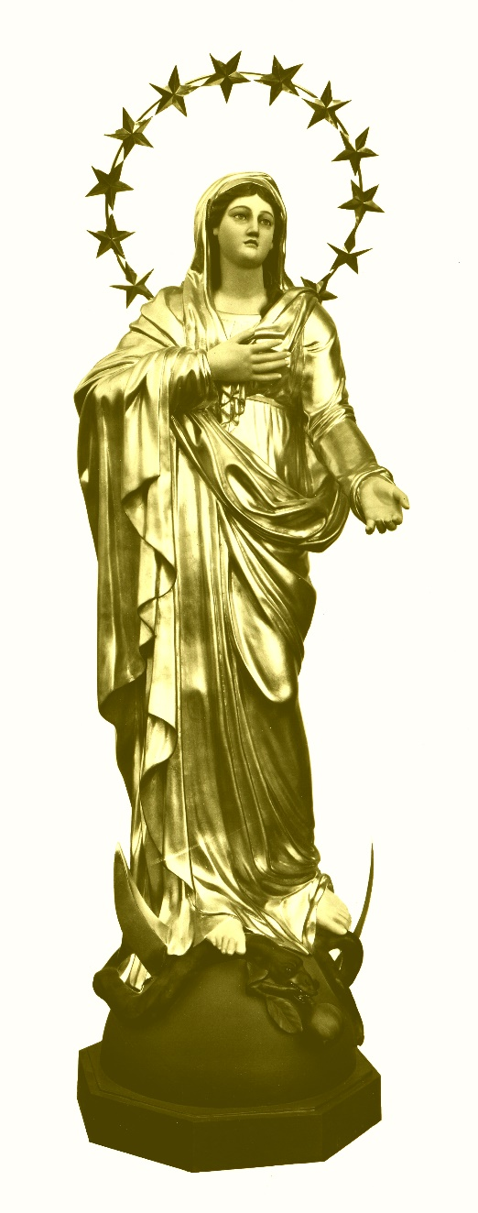

Constitutiones et Regulae, 1853, caput tertium, XIX.
Letter to Fr. Guibert, July 29, 1830: “Ecrits Oblats”, 7, p. 206-207.
Letter to p. Tempier, August 15, 1822, “Ecrits Oblats”, 6, p. 98-99.
Lettre circulaire, August 2, 1853, “Ecrits Oblats”, 12, p. 183-184.
Notes of the 1853 retreat, “Ecrits Oblats”, 15, p. 205.
Letter to p. Mille, 25 January 1831, “Ecrits Oblats”, 8, p. 12.
Letter to p. C. Baret, January 4, 1856, “Ecrits Oblats”, 12, p. 1.
Letter to p. Mouchette, April 24, 1855, “Ecrits Oblats”, 11, p. 266.
Letter to Fr. Courtes, 22 July 1828, “Ecrits Oblats”, 7, p. 167.
Letter to p. Lacombe, March 6, 1857, “Ecrits Oblats”, 2, p. 148.

